Title
Projections of Hourly Meteorology by County Based on the IM3/HyperFACETS Thermodynamic Global Warming (TGW) Simulations

Years
The dataset contains 40 years (1980-2019) of historical meteorology and 80 years (2020-2099) of projected meteorology across four different climate scenarios.

Scenarios
The four IM3 future climate scenarios span a wide but plausible range of climate scenario uncertainty (i.e., RCP4.5 vs RCP8.5) and climate model uncertainty (i.e., using models that are hotter or colder than the multi-model mean climate sensitivity).

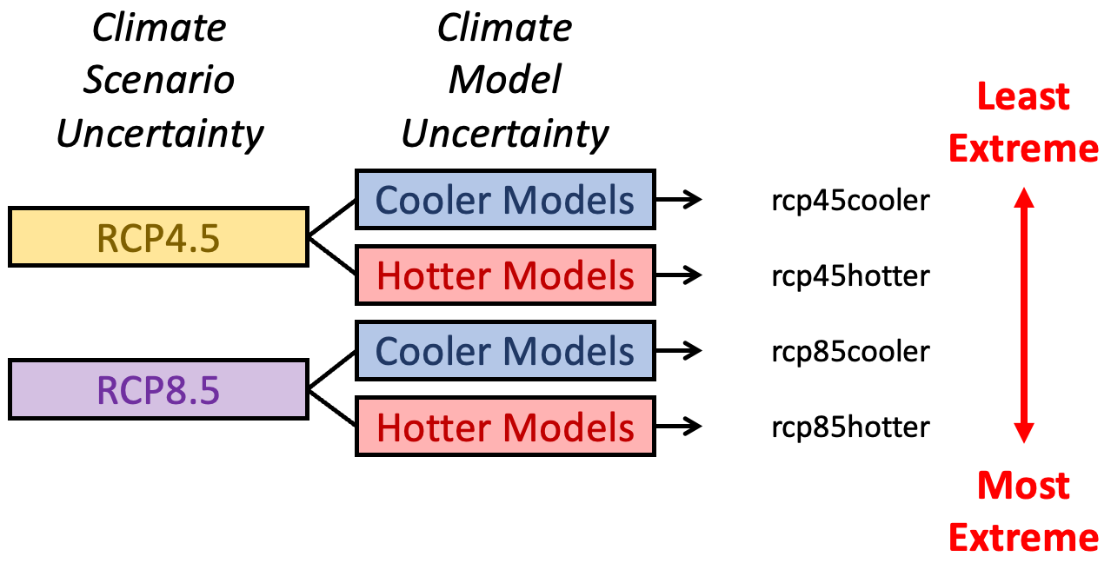

Variables
Variable | Name | Description | Units
County ID | FIPS | FIPS code for the county | -
Temperature | T2 | 2-m temperature | K
Specific Humidity | Q2 | 2-m water vapor mixing ratio | kg kg⁻¹
Wind Speed | U10 | 10-m east-west wind speed | m s⁻¹
Wind Speed | V10 | 10-m north-south wind speed | m s⁻¹
Shortwave Radiation | SWDOWN | Downwelling shortwave radiative flux at the surface | W m⁻²
Longwave Radiation | GLW | Downwelling longwave radiative flux at the surface | W m⁻²

